emeritalia
LABO FUME
FUME EXTRACTION SYSTEM FOR LASER AND WELDING
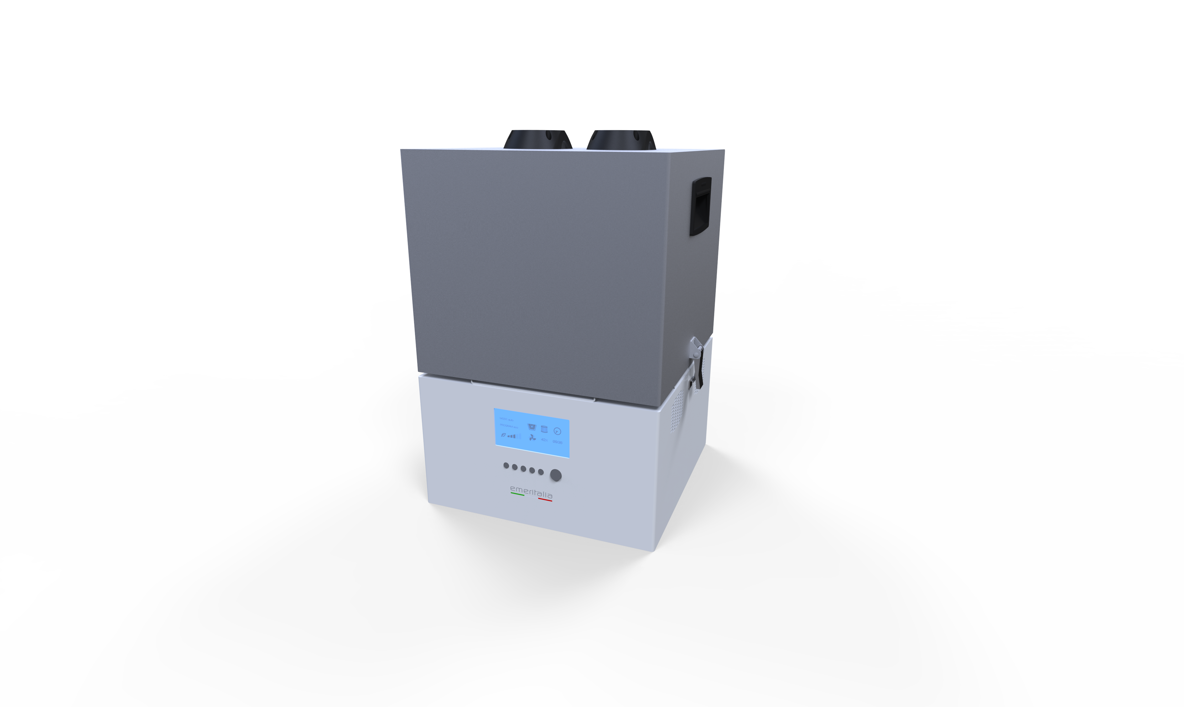
OPERATING AND MAINTENANCE MANUAL
Translation of the original Italian instructions
Rev. 01 - September 2026
EmerItalia - Via Euclide 2 - 20864 Agrate Brianza (MB) - Italy
Tel. +39 039 2027658 - produzione@emeritalia.it - www.emeritalia.it

Contents
1. General information
2. Description and operating principle
3. Technical data
4. Safety
5. Transport positioning and installation
6. Connection and commissioning
7. Operating the equipment
8. Filtration system
9. Maintenance
10. Troubleshooting
11. Decommissioning and disposal
12. Technical support and spare parts
13. Revision history

1. General information
This manual provides information on the installation, operation and routine maintenance of the LABO FUME extraction system. Keep it near the equipment and make it available to operators and maintenance personnel.

1.1 Product identification
Product | LABO FUME
Code | PV000800
Manufacturer | EmerItalia
Address | Via Euclide 2 - 20864 Agrate Brianza (MB), Italy
Contact details | +39 039 2027658 - produzione@emeritalia.it

1.2 Intended use
LABO FUME is an extraction system for fumes generated by cutting, laser processing and welding. The range is designed to extract fumes, dust, gases and vapours directly at their source.
The equipment has two extraction inlets. Compatibility with a specific process, material or substance must be checked by the person responsible for its use, taking into account the process and the substances generated.

1.3 Undocumented uses
Any other application not specified.

2. Description and operating principle
Contaminated air is drawn in through the two upper inlets. The airflow path shown in the technical documentation is: contaminated air inlet → HEPA H14 filter → activated carbon filter → motor → clean air outlet.
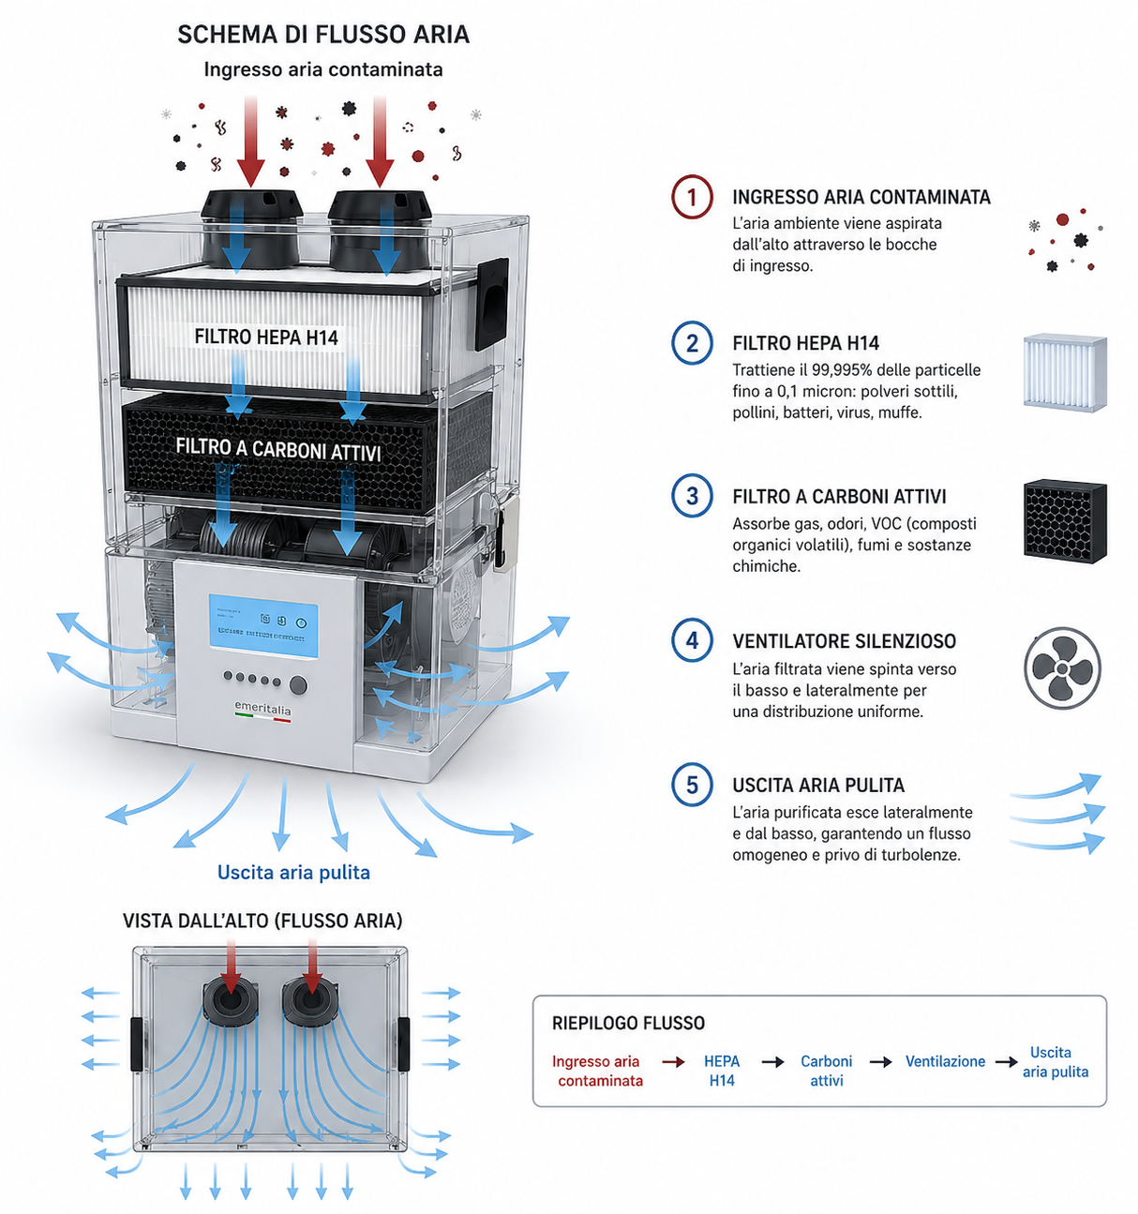
Figure 1 - LABO FUME airflow diagram
1. Contaminated air inlet - Air is drawn in from above through the inlet openings.
2. HEPA H14 filter - Captures 99.995% of particles down to 0.1 micron.
3. Activated carbon filter - Intended to adsorb gases, odours, VOCs, fumes and chemicals.
4. Fan - Filtered air is pushed downwards and sideways.
5. Clean air outlet - Purified air is discharged through the side and bottom outlets.

3. Technical data
Parameter | Value
Code | PV000300
Application | Fume extraction
Motor power | 750–1000 W
Voltage | 100–240 V
Motor type | Brushless
Vacuum | 12,000 Pa
Airflow | 300 m³/h
Noise level | < 59 dB(A)
Extraction inlets | 2
Filtration | HEPA H14 + activated carbon
Operating mode | EMC (as stated in the source data sheet; meaning to be confirmed)
Sockets/accessories | Schuko + RJ45
Dimensions (W × D × H) | 350 × 350 × 500 mm
Listed accessories | Flexible hose
Filter surface area | HEPA 3 m² – activated carbon 3.4 kg
Weight | 25

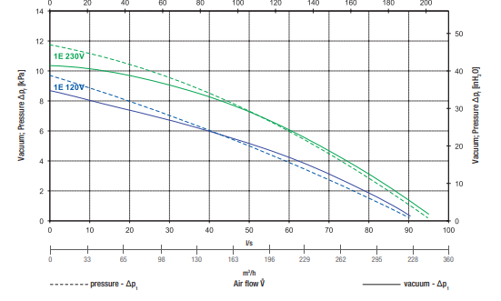
Figure 2 - Performance curve provided in the technical documentation.

4. Safety
The equipment must only be used by personnel who have read and understood this manual and the instructions for the process to which it is connected.
- Before cleaning, opening or maintaining the equipment, stop it and disconnect it from the power supply.
- Do not obstruct the extraction inlets or air outlets.
- Use hoses and accessories suitable for the process and ensure that all connections are securely fastened.
- Contaminated filters may contain substances from the extraction process. Handle them using the protective measures required for the substances involved.
- Do not use the equipment if the cable, connectors, housing or fastening mechanisms are damaged.
- Do not modify the equipment or bypass protective devices without the manufacturer’s authorisation.

4.1 Personal protective equipment
The personal protective equipment (PPE) required depends on the material and the connected process (laser, welding or another authorised process). When maintaining the filters, also follow the safety data sheets for the extracted substances and the workplace procedures.

5. Transport positioning and installation
- Remove the unit from its packaging and check for visible damage.
- Place LABO FUME on a stable, level surface suitable for the weight of the equipment.
- Keep the grilles and air outlet areas clear.
- Position the unit so that the power cable and extraction inlets remain accessible.
- Avoid placing the unit in areas directly exposed to liquids or heat sources.
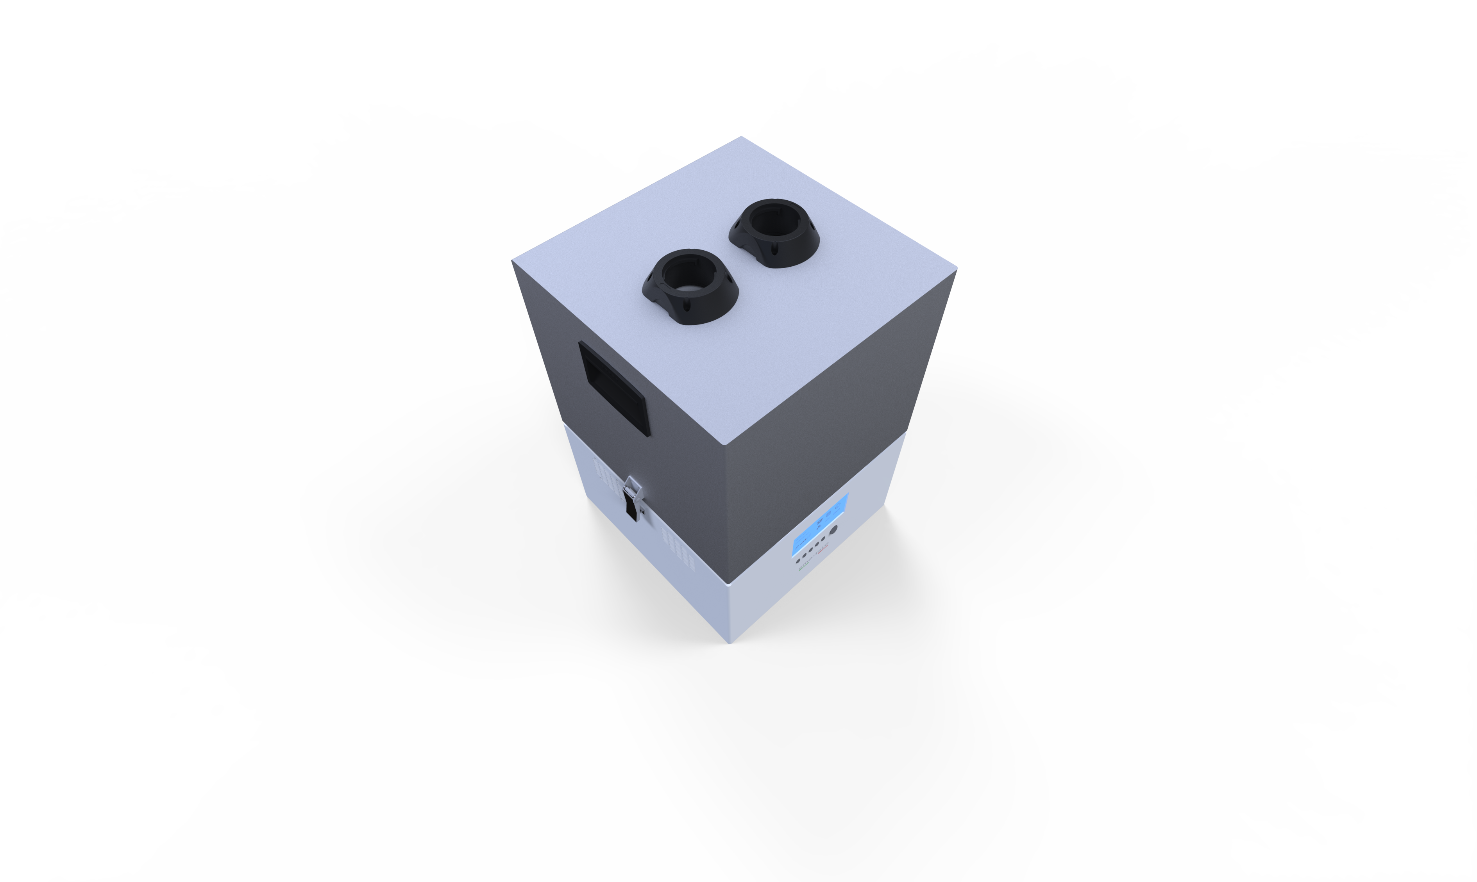
Figure 3 - Top view showing the two extraction inlets.

6. Connection and commissioning
Connect one or two extraction hoses to the upper inlets. Check that the hoses are not crushed or obstructed.
Before connecting the power supply, check that the available voltage is compatible with the 100–240 V range stated in the technical data. Then connect the equipment according to the electrical configuration supplied with the unit.

6.1 Start-up and controls

ON/OFF button: switches the extractor on and off.
Automatic/Manual mode: switches between automatic and manual operation. In automatic mode, extraction starts automatically when the connected equipment is switched on and stops a few seconds after that equipment is switched off.
In AUTO mode, use the Schuko socket to connect 230 V equipment. For a low-voltage connection, use the RJ45 connector (positive: pin 6; negative: pin 5).
Extraction power: press the + or − buttons to adjust extraction power in 25% increments (25%, 50%, 75%, 100%).
Setting the time: press and hold the button with the clock symbol until the digits on the display start flashing. Use the + or − buttons to set the required hour. Press the clock button again to set the minutes. Press it a third time to confirm the settings.
Filter cleaning – “shake-off” function: this button is not available on LABO FUME.

7. Operating the equipment
The LABO FUME front panel includes a display and several physical controls. The button functions and operating modes are described in section 6.1 Start-up and controls.
Figure 4 - Front view of the equipment.
General operating sequence:
- Check that the filters, lid and connections are correctly installed.
- Connect the hoses to the extraction inlets.
- Supply power to the unit and use the designated ON/OFF control.
- Start extraction before beginning the process that generates fumes or dust.
- At the end of the process, stop the unit using the control panel procedure.

8. Filtration system

8.1 HEPA H14 filter
This is the first filtration stage shown. It captures 99.995% of particles down to 0.1 micron, including fine dust, pollen, bacteria, viruses and mould.

8.2 Activated carbon filter
In the diagram provided, this filter is located downstream of the HEPA filter and is intended to adsorb gases, odours, volatile organic compounds (VOCs), fumes and chemicals.

8.3 Filter replacement
Release the latches and lift the lid. Replace the filter, then refit the lid and secure it with the latches.

9. Maintenance
Task | Frequency | Instructions
Check hoses and fittings | Before use | Check for obstructions, damage and secure fastening.
Check air grilles | Periodically | Keep free of deposits and obstructions.
External cleaning | As needed | Disconnect the unit; prevent liquids from entering.
Check filters | To be defined | The source does not specify replacement frequency or criteria.
Internal servicing | To be defined | Follow EmerItalia procedures.
Do not use compressed air or other filter cleaning methods unless expressly authorised for the specific replacement filter.

10. Troubleshooting
Symptom | Preliminary checks | Action
The unit does not start | Power supply, cable, main switch | If the problem persists, contact technical support.
Reduced extraction | Blocked/bent hoses; filters; extraction inlets | Remove obstructions; check the filters using the authorised procedure.
Unusual noise | Obstructions, fastenings, foreign objects | Stop the unit; do not open the motor assembly without authorisation.
Alarm/display | Displayed code or message | Alarm functions and codes are not available in the source: contact EmerItalia technical support.

12. Technical support and spare parts
For technical support and spare parts, contact:
EmerItalia
Via Euclide 2 - 20864 Agrate Brianza (MB) - Italy
Tel. +39 039 2027658
E-mail: produzione@emeritalia.it
Web: www.emeritalia.it
To identify the unit correctly, provide at least the LABO FUME model name, code PV000300 and the information on the product nameplate.

