

LABO BOX

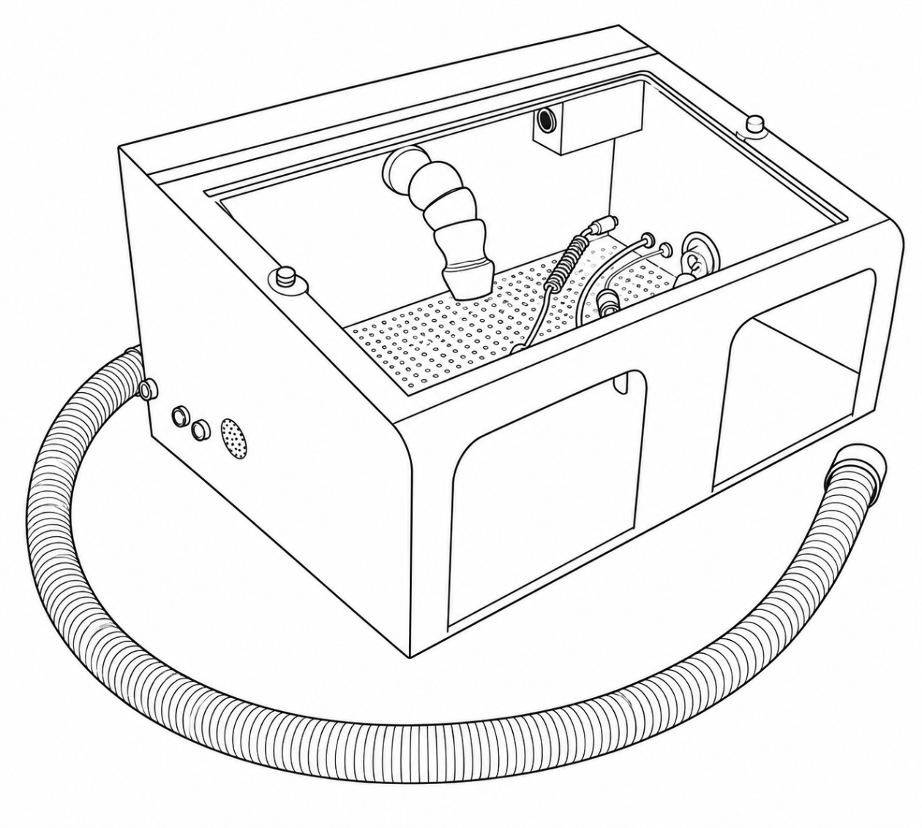

EmerItalia srl - Via Euclide 2 -20864 Agrate Brianza tel 0392027658
info@emeritalia.it

The unit is manufactured compliance with current technical and safety standards, in accordance with the provisions of the Community Machinery Directive 2006/42/EEC and subsequent amendments and additions.
Each piece of equipment is individually tested for all functional aspects, then subjected to examination by an automatic test facility that ensures compliance with the established limits.

2006/42/CE (direttiva macchine) 2014/35/UE (direttiva bassa tensione)
2014/30/UE (direttiva compatibilità elettromagnetica)

Le seguenti norme armonizzate sono state applicate:
EN 61010-1:2010; EN ISO 12100:2010; EN 61326-1:2013

WARNING INFORMATION

IMPORTANT !
Before installing the apparatus read carefully this manual and keep it for future consultations.

WARNING
- Do follow carefully all the indications brought back in this manual.
- During all the maintenance operations disconnect the power cord from the electrical outlet, and/or discon-nect the compressed air and/or the water attack and/or other attacks of external parts to the apparatus.
- Do not introduce stranger objects inside the unit during the maintenance operations.
- Use only the accessories in equipment for the filling operations and/or maintenance.
- Do not execute different operations of maintenance from those brought back in the manual. Whichever operation not contempled in this manual, can involve risks. For operations of this type, contact the techni-cal service.
- Before turning on the unit and connecting the power cord to the electrical outlet, make sure that the vol-tage corresponds to the one brought back on the fabrication nameplate placed on the back part of the ap-paratus.

CAUTION
- Do not make any maintenance operation when the power cord is connected: FULGURATION DANGER!
- Use only genuine spare parts. Placing not genuine spare parts can void your warranty, moreover can make the apparatus not in compliance with the norms, and dangerous when in use.

UNPACK
- Verify integrity of the pack at the moment of the reception of the apparatus.
- Verify that in the packaging all the parts and the supplied accessories of series are contained together with the apparatus.

INSTALLATION
Take the unit out of the packaging and place it on a flat surface strong enough to bear its weight.

GUIDE TO COMMON QUESTIONS
The apparatus is not turning on:
- Control that the power cord plug is properly connected to the electrical outlet.
- Check that power is on at the electrical outlet.

Carried out these controls, in case the apparatus still presents disadvantages, contact the customers' techni-cal service.

Technical Specifications
Mains voltage: 230 V, 50 Hz 120 V, 60 Hz Power consumption, lighting: 40 W (230 V)
Dimensions (WxHxD): 600X400X300
Weight :15 kg

Warranty
Provided the unit is properly used,
Veradenta warrants
all components for a period of 1 years.
of the Verabox Mini

