Verabox Mini User Manuel
Date: 27/02/2020
Veradenta Dental LTD STI
Ivedik OSB 1378 Sok No:11 Yenimahalle/Ankara/Turkey info@veradenta.com * www.veradenta.com
0090 542 383 83 72
LABO DUST

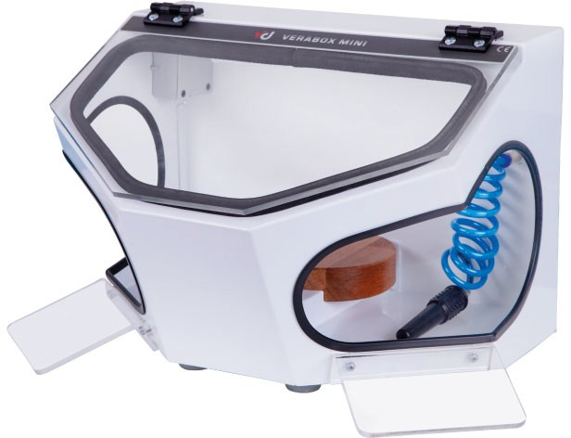
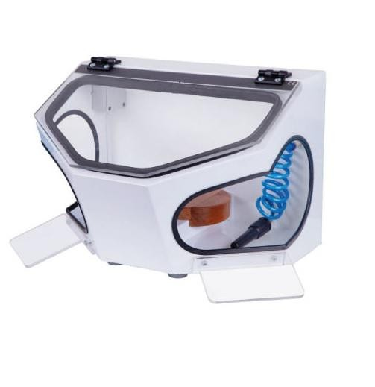

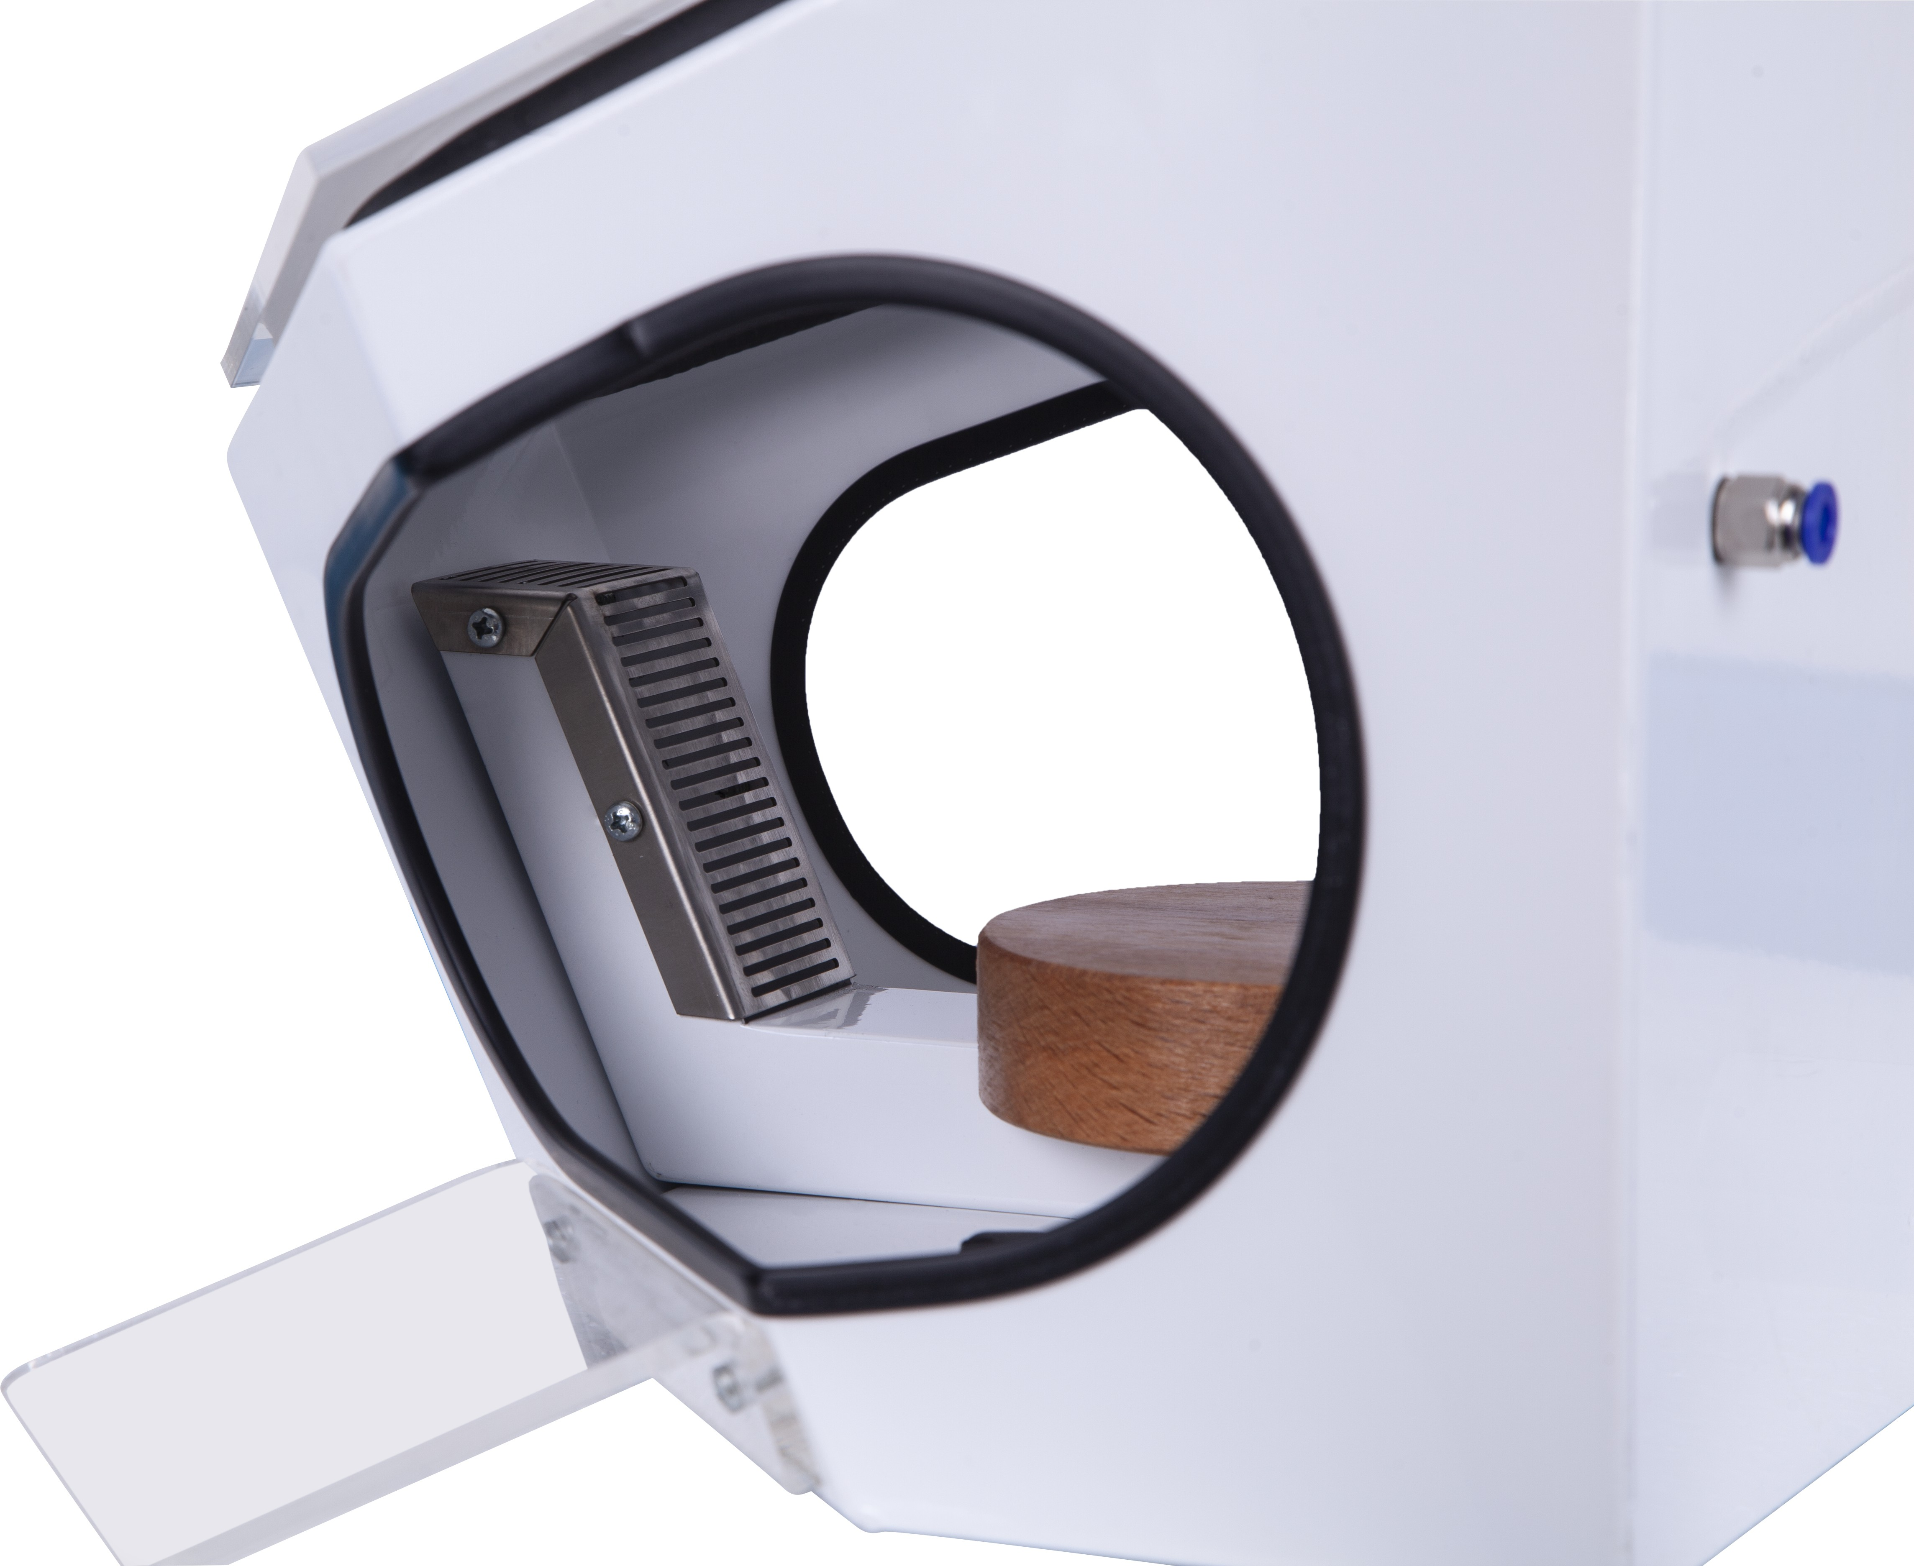
Air Connection
Figure-1
Removeable suction part (Stainless Steel)

Figure-2

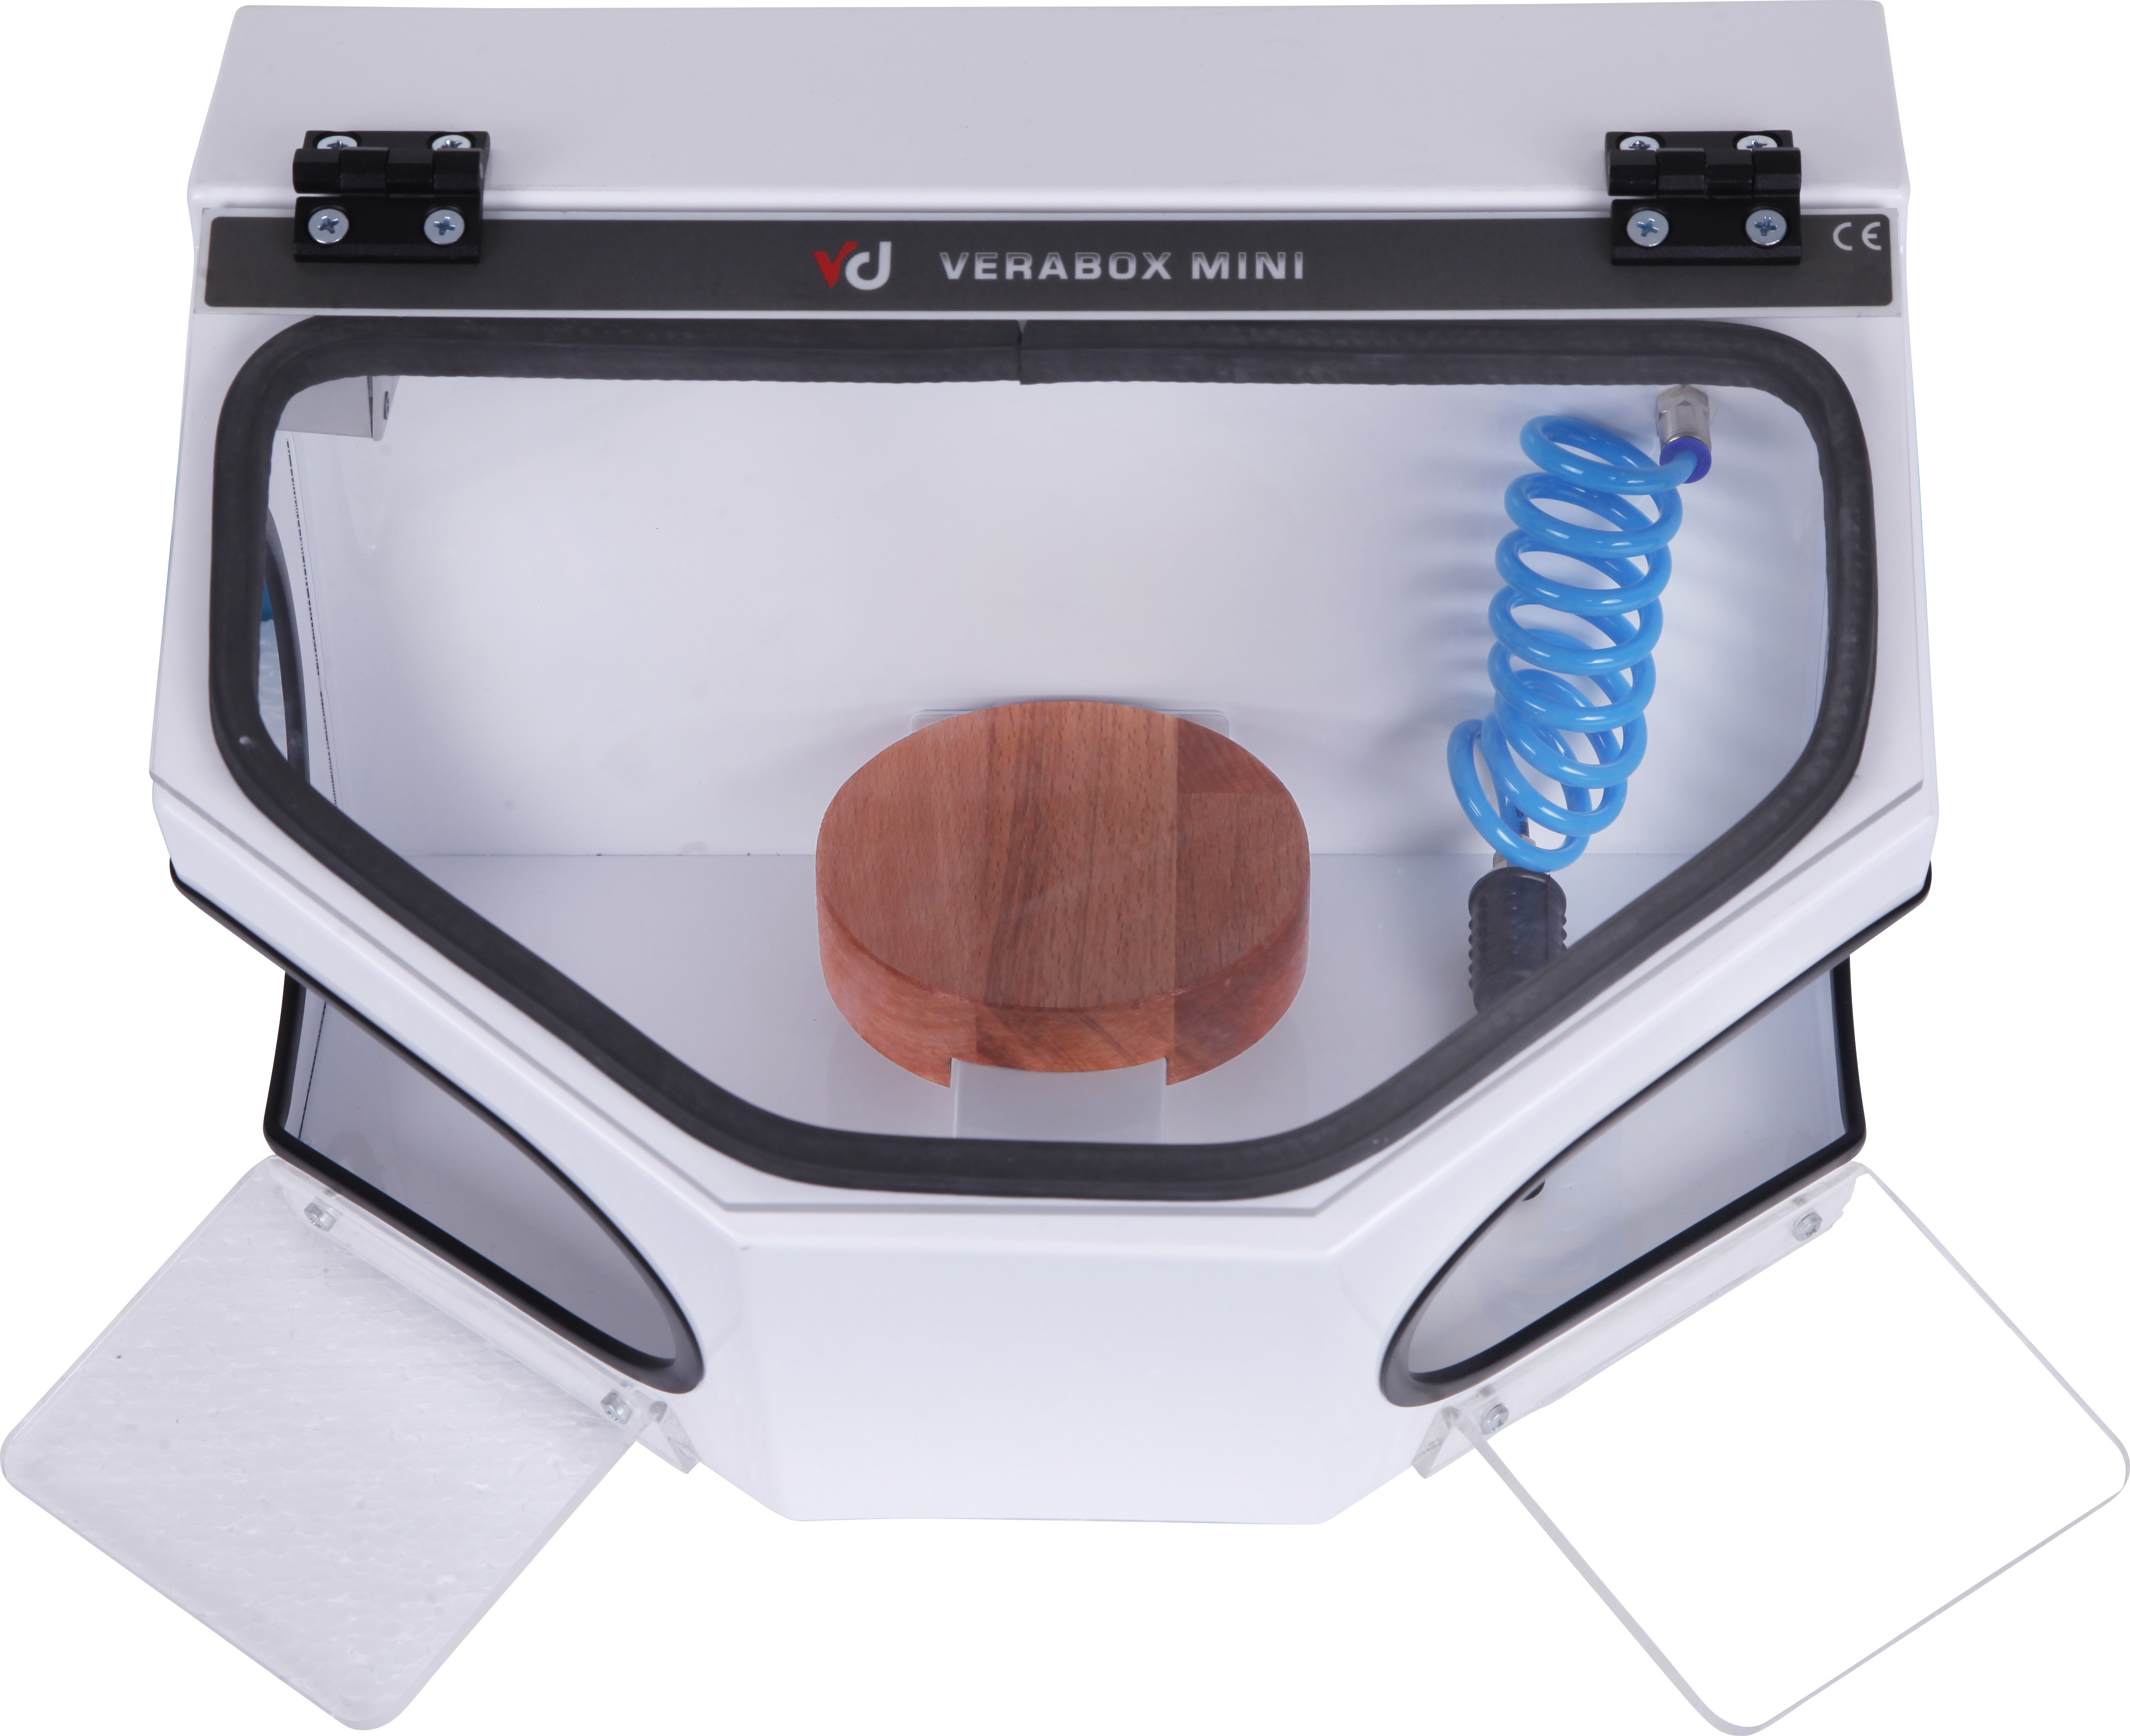
Pleksiglass protector

Plastic Arm-rest
Wooden working pad

STANDARD SUPPLY PLASTIC PAD

Figure-3

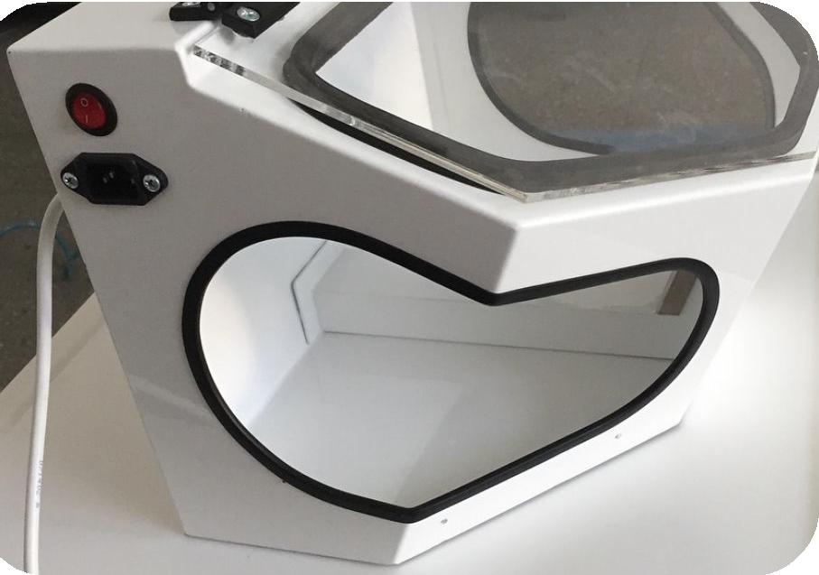
Light On/Off button
Socket for Cable power supply

Figure-4

If there is any damage to the protective plexiglass, you can replace it by removing the bolts.

Figure-5
Back side of Verabox mini

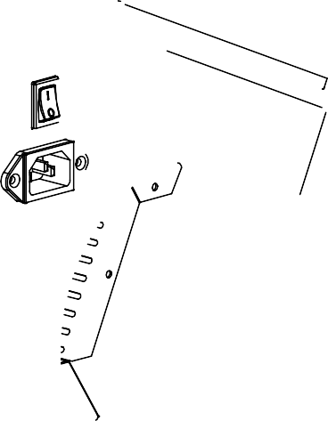
Suction Connection (Dia. 38mm)

WARNING INFORMATION

- Improper use of grinding tools in the extraction box carries with it the potential risk of eye and skin injuries.
- Never grind in the direction of your eyes or uncovered areas of skin!
Verabox Mini User Manuel
Date: 27/02/2020
• The verabox mini is not suitable for use in conjunction with blasting units.
- Never work with the viewing pane open!
- Always wear appropriate eye protection when operating the unit! Failure to wear eye protection can result in eye injuries due to airborne particles.
- Always disconnect the unit from the mains power supply prior to replacing the LED light.
- Never press on or bend the lamp body during replacement (breakage risk). If necessary, wear gloves or use a cloth.
- Always inspect the electric input lines prior to operation. Units with damaged input lines may not be operated.

- Liability Exclusion -
Veradenta LTD STI shall be absolved from all claims for damages or warranty if:

- The product is employed for any purposes other than those cited in the operating instructions;
- The product continues to be employed, despite obvious safety faults or damage;
- The product is subjected to mechanical impacts or is dropped.

Before connecting the unit to the mains power supply, compare it with the specifications of the local mains power grid. Setting up the ınit and connecting it to an extractor connect the suction hose to the suction tube
Environmental conditions

- The ambient temperature should be between 5-40 degrees Celsius.
- With a mains power supply whose voltage fluctuations do not exceed 10% of the rated value
- Under over-voltage category II conditions.

Technical Specifications
Mains voltage: 230 V, 50 Hz 120 V, 60 Hz Power consumption, lighting: 40 W (230 V) Power cord length: 1,5 meter
Dimensions (WxHxD): 380 x 285 x 300 mm Weight : 4 kg

Warranty
Provided the unit is properly used,
Veradenta warrants
all components for a period of 2 years.
of the Verabox Mini

EmerItalia srl - Via Euclide 2 -20864 Agrate Brianza tel 0392027658
info@emeritalia.it

