
PROFESSIONAL VACUUM CLEANER
 USER AND MAINTENANCE MANUAL

DESCRIPTION
The dust collector is a powerful and reliable professional vacuum cleaner designed to support the dust-producing machinery in the working cycle of a dental, gold or silversmith laboratory.
The high speed, single stage motor quickly sucks up dusty particles from the production sources and draws them into the 3 filter stages. The largest particles are retained in a first paper bag, the smallest in a second nylon bag and the smallest (and most harmful) particles are retained on the walls of the internal microfilter cartridge.
This model has a very important advantage: an electromagnetic system of automatic shaking of the microfilter cartridge, which allows everything that has been retained on its large surface to precipitate, allowing even greater operating autonomy.
It can be easily connected to dry grinders, sandblasters, workbenches, etc., even for two users at the same time.
Suitable for vacuuming dust and small debris, not suitable for vacuuming liquids.

TECHNICAL REFERENCE REGULATIONS AND TEST MODES
The vacuum cleaner is manufactured compliance with current technical and safety standards, in accordance with the provisions of the Community Machinery Directive 2006/42/EEC and subsequent amendments and additions.
Each piece of equipment is individually tested for all functional aspects, then subjected to examination by an automatic test facility that ensures compliance with the established limits.
NOISE - Values measured in accordance with EN 60704 -1 (1996) / EN 60704 -2 - 1 (2000). The A measurement of the machine's sound pressure level is ≤ 59 dB (A).

EN60335-1:2012+A1:2014, EN 60335-2-69:2012, EN 55014-1:2006+A1:2009+A2:2011, EN 55014-2:2015, EN 61000-3-2:2014, EN 61000-3-3-:2013

2006/42/CE - 2014/30/UE - 2011/65/UE

TECHNICAL SPECIFICATIONS

Description | WHISP-R PRO
dimensions | 240x480x370mm
Dimensions (packed) | 350x540x400 mm
weight | 13,0 kg
Weight (packed) | 16,0 kg
motor | 1000W
volume | 50 L/s
vacuum | 2400mm/H2O
noise level | <59 dB (A)

DEMOLITION AND WASTE DISPOSAL

This equipment is an EEE (electrical or electronic equipment that is dependent on electric currents or electromagnetic fields for proper functioning) according to international standards, and therefore, once it has become unserviceable, it must be collected separately and sent for environmentally sound reuse in accordance with Directive 2002/96/EEC.
Do not throw discarded power tools in the household waste!

GENERAL PRECAUTIONS
- WARNING: this unit may only be used for dry vacuuming and may not be used or stored outdoors in damp conditions.
- Any use other than those indicated in this manual may constitute a hazard and should therefore be avoided
- When the appliance is in operation, avoid placing the suction orifice near sensitive parts of the body such as the eyes, mouth, ears
- Before use, the appliance must be correctly assembled in all its parts
- Ensure that the voltage value indicated on the motor block corresponds to the energy value to which the appliance is to be connected
- CAUTION: Do not suck-up flammable substances (e.g. chimney ash), explosive, toxic or hazardous to health
- Do not suck-up liquids of any kind
- Do not leave the appliance running unattended
- Always unplug the appliance from the mains socket before carrying out any work on the appliance or when it is left unattended or within reach of children or people who are not aware of their actions
- Never pull or lift the appliance using the electrical cord
- Do not immerse the appliance in water for cleaning or wash it with jets of water
- Check the power cable regularly for damage, such as cracks or ageing. Replace the cable before further use
- When using extension cords, ensure that they rest on dry surfaces and are protected from splashing water
- Maintenance and repairs should always be carried out by specialised personnel; any parts that fail should only be replaced with original spare parts.
- Check filters regularly and clean or replace them if necessary.
- Do not run the vacuum cleaner over the mains cable as this could damage the insulating sheath.
- The manufacturer accepts no liability for damage caused to persons or property as a result of non-compliance with these instructions or if the appliance is used unreasonably.

WARRANTY

The warranty period for our units is 12 months. In case of any defects found on the unit during this period, please inform your reference dental depot or contact our service team directly.

The unit must only be used in a technically impeccable condition. If defects occur that could pose a risk to employees or third parties, the unit can only be used again after it has been repaired.
The guarantee does not cover damage resulting from improper use, external mechanical influences, damage during transport or unauthorised work on the unit by unqualified personnel.

INSTALLATION INSTRUCTIONS
Open the shipping carton and carefully remove the packing material. Carefully unpack the unit and the supplied accessories, ensuring that all accessories are present and in good condition. Place the unit horizontally on a stable, level surface, avoiding outdoor or poorly ventilated areas. Position the unit so that the work area is clear and does not obstruct operation, taking into account the size of the unit. Ensure that there is a space of approximately 10 cm on each side of the unit to allow for proper air circulation and heat dissipation.

Ensure that the unit has reached room temperature before use.
- Check that all filters are in place.
- Check that the microfine dust filter bag is firmly secured in the dust container and that all other filters are correctly fitted.
- Insert the tube into the tube inlet and turn clockwise to lock.

- Plug the machine into a wall outlet, making sure that the voltage of the machine matches that of the household outlet.

INSTRUCTIONS FOR USE
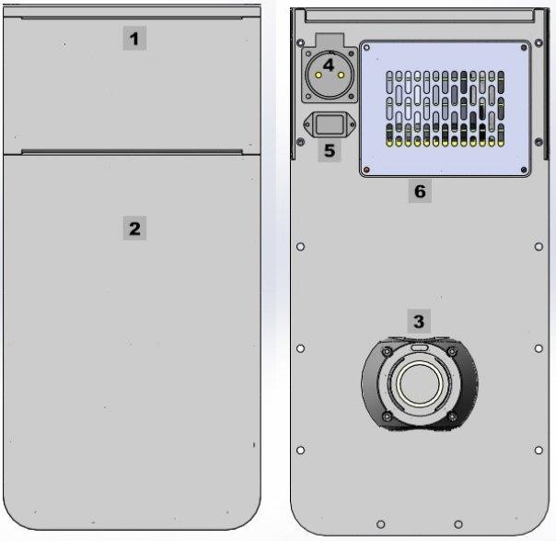
POS. | Front
1 | Control panel
2 | Dust-proof door

POS. | Rear
3 | Hose connection
4 | Socket for connection unit
5 | Socket for power cable
6 | HEPA filter access door

CONTROL PANEL

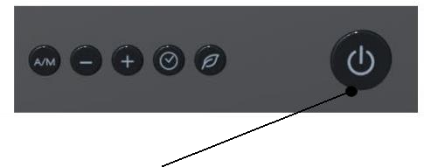

ON/OFF button.
Automatic/Manual mode: Press the A/M button to switch between automatic and manual mode. In automatic mode, suction is automatically activated when the connected appliance is switched on and deactivated with a delay of a few seconds when the appliance is switched off.

Suction power: press the (+/-) button to adjust the suction power in 25% increments (25%, 50%, 75%, 100%).

Time setting: press and hold the clock symbol button until the digits on the display start flashing.
Use the + or - button to set the desired time.
Press the button again to move to the minutes setting. Press the button a third time to confirm the setting.

Filter cleaning - shake-off function: To clean the main filter, press the button with the leaf symbol .
To reset the filter saturation percentage, press and hold the same button with the engine off/standby until an acoustic signal is heard.

Setting the automatic start: Disconnect the power plug to ensure that the cleaner is completely switched off.
Plug the machine's power cable into the socket 4.
Press and hold the A/M and Leaf buttons simultaneously while reconnecting the cleaner to the mains.
Continue to hold down the buttons until 'ST 000' appears on the display.
Use the + or - buttons to set the desired value according to the suction power of the appliance (between 30 and 250).
Press the button with the clock symbol to save and confirm the set value.
Operating time (plug in device)
Press and hold the + and - buttons simultaneously while connecting the cable to socket 4.
Wait until 'T0 / ON 00:00' appears on the display. T0: Displays the total running time of the machine.
ON: Displays the actual running time of the engine (example:5 = 50 hours).

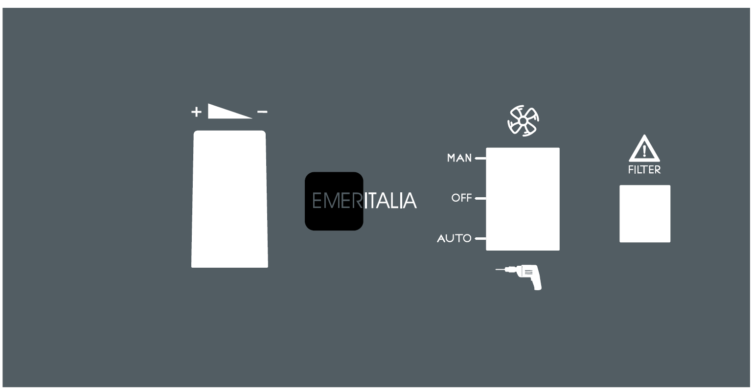

MAN/OFF/AUTO button: turns the extractor on and off.

Automatic/Manual Mode: allows you to switch between automatic and manual modes. In automatic mode, suction automatically activates when the connected appliance is turned on and deactivates, with a delay of a few seconds, after the appliance is turned off.

Adjusting automatic start: turn the screw on the knob holder plate.
If the extractor starts without consent, turn counterclockwise.
If the extractor does not start, turn clockwise.

Suction power: turn the knob to increase or decrease the suction power.

MAINTENANCE

/!\  ATTENTION | Before carrying out any maintenance operation on the machine or on the installations, disconnect the cable from the socket in order to completely insulate the equipment from the electrical network. In case of any doubts or possibility of error, please contact our Technical service in order to avoid any damages or risks.
The three filters must be replaced regularly, depending on the frequency of use and the type of dust collected.

Cartridge filter: replacement is recommended every 4-6 months, depending on use and the type of dust collected.

Main filter: clean regularly under running water or with a soft brush to avoid damage to the surface. This filter should also be replaced every 4-6 months, depending on use and the type of dust collected.

Filter bag: check regularly and replace if necessary. It is recommended that only original filter bags are used.

The HEPA filter is not washable and must be replaced in accordance with the maintenance instructions.

  - Replacing and cleaning the filter cartridge

Open the front panel (H) by pulling the handle and remove the filter bag housing (V). Rotate and remove the filter (M). Insert the new cartridge filter and turn it until it is fully seated on the fitting (F).

The filter is washable, so remove it regularly (about once a month, depending on use) and clean it under running water. Allow it to dry completely before replacing.
We recommend a complete replacement every 4-6 months.

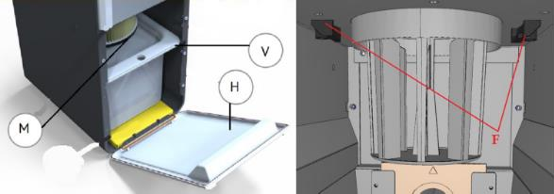

Replacing the filter bag

Change the filter bag according to the degree of use and in any case when it is full. To do this, open the front panel (H) by pulling the handle, then remove the filter bag box (V) and the filter bag itself. Insert the flange of the new bag into the holder (T) and replace the filter bag box in the suction duct. It is recommended to replace the filter bag every 4-6 months, depending on the frequency of use.
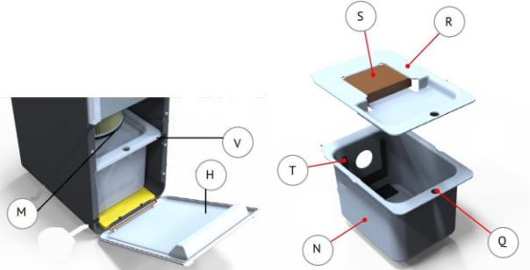

Replacing the HEPA filter

Remove the cover and grid screws (6) at the rear of the unit and remove the HEPA filter grid.
Replace the filter by removing the old filter by pulling it upwards as shown and inserting the new filter, then replace the HEPA filter grid and cover with the screws.

This filter is NOT washable.
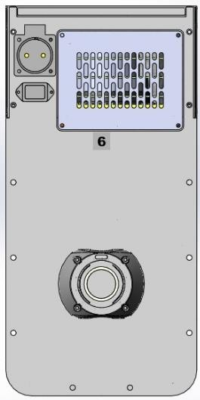
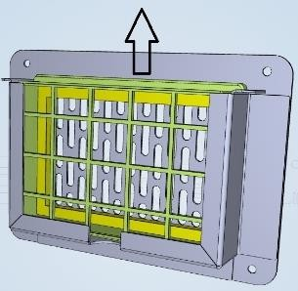

CLEANING

/!\  CAUTION | CAUTION Disconnect the power plug before carrying out maintenance work. The identification plate must always be legible and must not be removed.
To ensure optimum performance, it is important to clean the unit regularly by removing any external dirt. Only use cold cleaners to avoid damaging the paint or lettering on the surface.

Routine maintenance does not require the use of chemical additives: just use gentle cleaning tools such as sponges, soft cloths and cold cleaners.

